ProjectMeLT XRXS for RPG Maker XP

http://xrxs.at-ninja.jp/MeLT.htm

Components:

Main menu layout template

Plug-in A1: command stream
Plug-in A2: command plate

Plug-in B1: Camp Battles
Plug-in B2: Sharp Hunters
Plug- in B3: Fine partner

Plug-in C1: Co Inline
Plug-in C2: Playing time clock
Plug-in C3: Map Name header
Plug-in C4: Variable A
Plug-in C5: Variable B
Plug-in C6: Variable C
Plug-in C7: Variable D
Plug-in C8: Map name sidebar
Plug-in C9: Mission footer

Script Set-up:

The main menu layout template refered to as "Main Module XRXS_MeLT" goes after all standard RPG Maker Scripts (1st custom script).

Menu screen layouts are handled by plugins - include only one plugin type A and one plugin Type B with any combinations of plugin types C.

Plugin A: Window_MenuCommand

Plugin B: Window_MenuStatus

Plugin c1: Window_MenuGold
Plugin C2: Window_MenuPlayTime
Plugin C3: Window_MenuMapName
Plugin C4: Window_MenuVariable1
Plugin C5: Window_MenuVariable2
Plugin C6: Window_MenuVariable3
Plugin C7: Window_MenuVariable4

Place "Main" at the end of the plugins section.XRXS Script Components

Plug-in A
Plug-in A1: Command stream  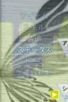  Command selection with text highlighting  active selections - |  | Plug A2: Command plate  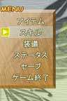  Command selection with cursor highlighting each selection. Menu background editable.
Plug-in B
Plug-B1: Camp Battles  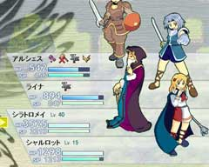  • Diagonal style layout  • Uses character combat battlers  • Combat battlers can be surpassed |  | Plug-in B2: Sharp Hunters  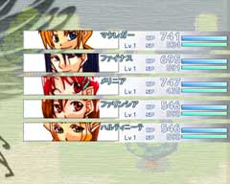  • Supports between 5-6 party members  • Set the picture menu of only 200 × 40 size  • When the face is thin and non-combat.
Plug-B3: Fine partner
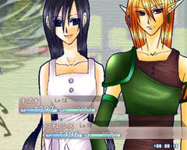
• Bold design using a standing picture
• Only 1-2 can be viewed at one time
• Set your own standing picture for every actor
Plug-in C
Plug-C1: inline co 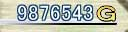
Plug C2: Playing time clock 
Plug-C3: Map Name header 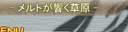
Plug-C4 ~ 7: Variable A ~ D 
Plug-C8: Map name sidebar 
Plug-in C9: Mission footer 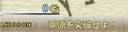
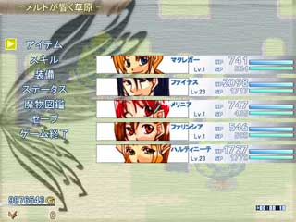
Menu skins can be changed along with various combination of different plug-in and graphics to change the layout and style of the menu in a number of different ways!

